**LAB 3 Report**

Ashish Natesh- 20788766

Justin Cai- xxxxxxx

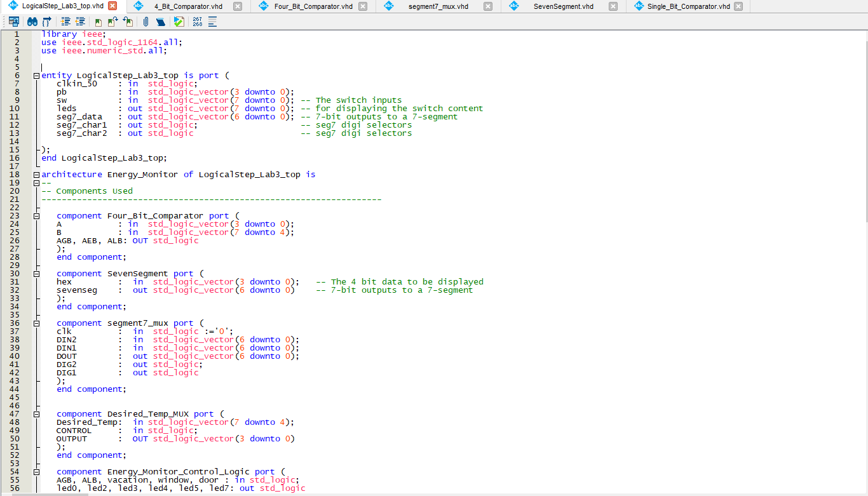Lab 3 Top file

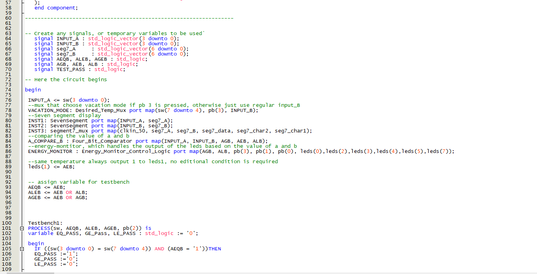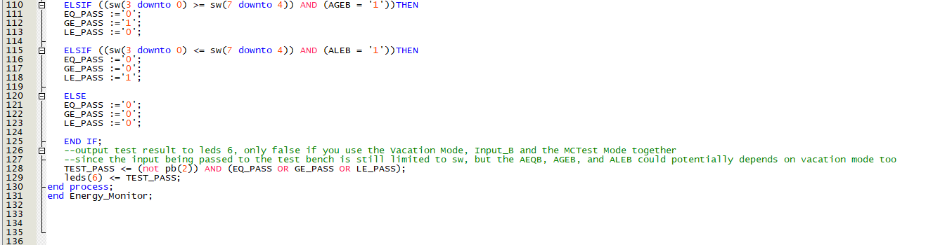

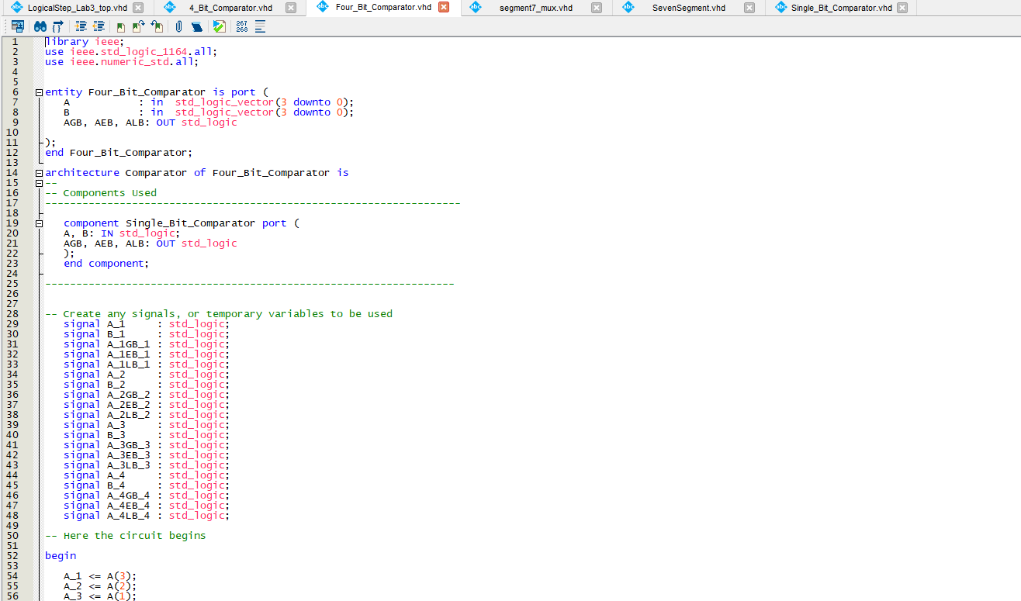Four- bit Comparator file

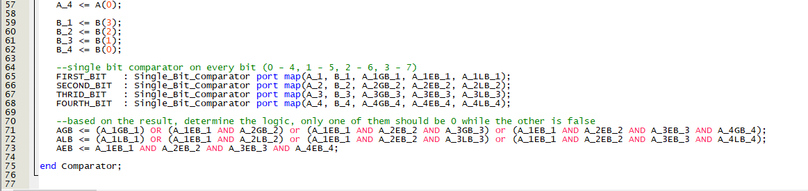

Single-Bit Comparator file

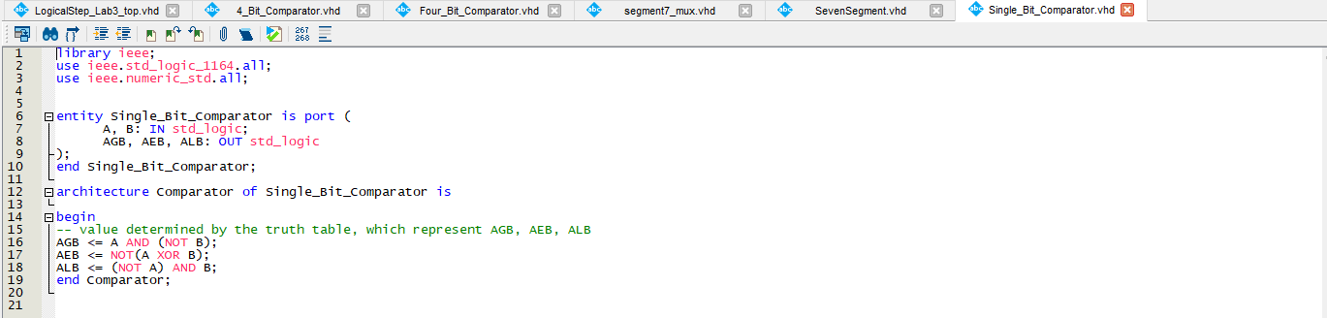

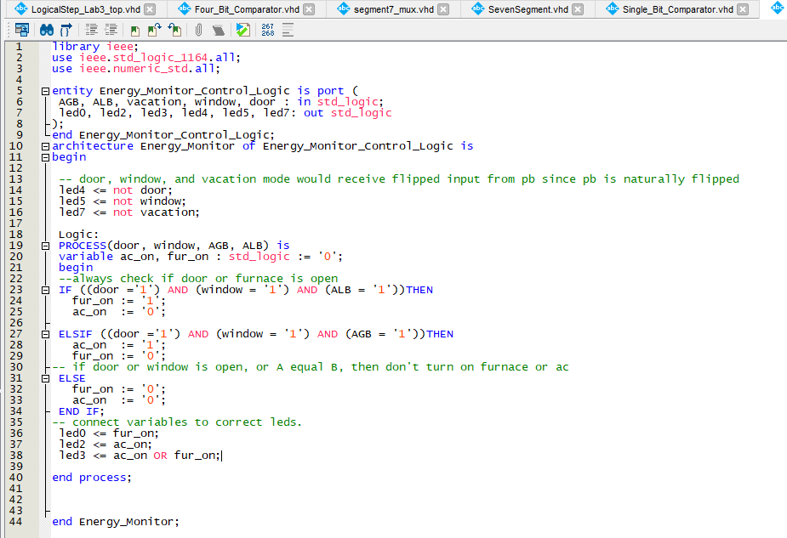Energy Monitor Control Logic File

Desired Temp Mux

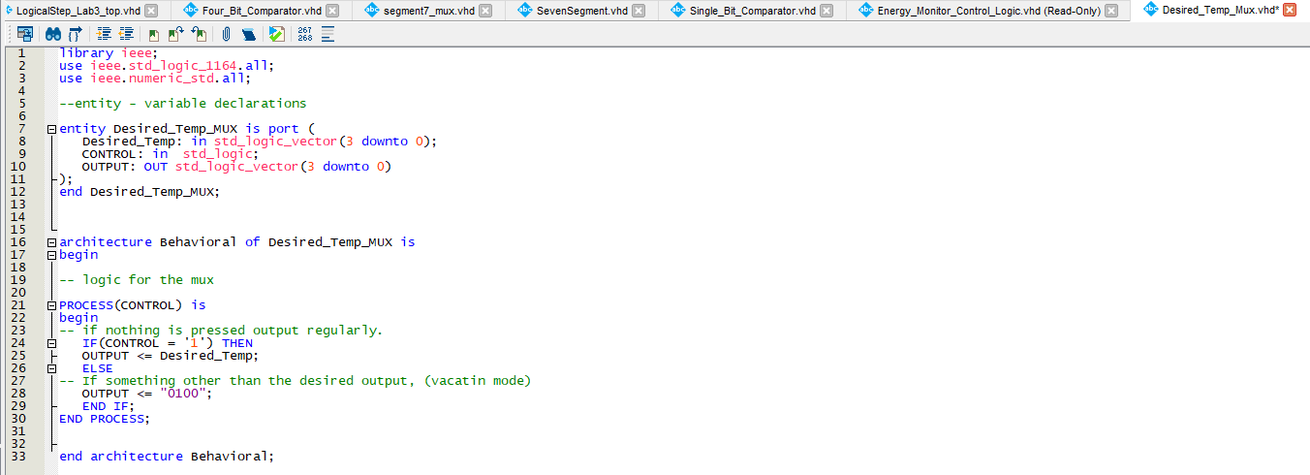

Truth Table

|  |  |  |  |  |  |  |  |  |  |  |  |  |  |  |
| --- | --- | --- | --- | --- | --- | --- | --- | --- | --- | --- | --- | --- | --- | --- |
| Comparison Inputs from 1 –Bit Comparators | | | | | | | | | | | | 4-Bit Comparator Outputs | | |
| A3<B3 | A3=B3 | A3>B3 | A2<B2 | A2=B2 | A2>B2 | A1<B1 | A1=12 | A1>B1 | A0<B0 | A0=B0 | A0>B0 | A<B | A=B | A>B |
| X | X | 1 | x | x | x | x | x | x | x | x | x | 0 | 0 | 1 |
| 1 | x | X | x | x | x | x | x | x | x | x | x | 1 | 0 | 0 |
| x | 1 | x | x | x | 1 | x | x | x | x | x | **x** | 0 | 0 | 1 |
| 0 | 1 | 0 | 1 | x | x | x | x | x | x | x | X | 1 | 0 | 0 |
| 0 | 1 | 0 | x | 1 | x | x | x | 1 | x | x | x | 0 | 0 | 1 |
| 0 | 1 | 0 | x | 1 | x | 1 | x | x | X | X | X | 1 | 0 | 0 |
| 0 | 1 | 0 | x | 1 | x | x | 1 | x | x | x | 1 | 0 | 0 | 1 |
| 0 | 1 | 0 | x | 1 | x | x | 1 | x | 1 | x | x | 1 | 0 | 0 |
| x | 1 | x | x | 1 | x | x | 1 | x | x | 1 | x | 0 | 1 | 0 |

RTL Viewer for the Top file

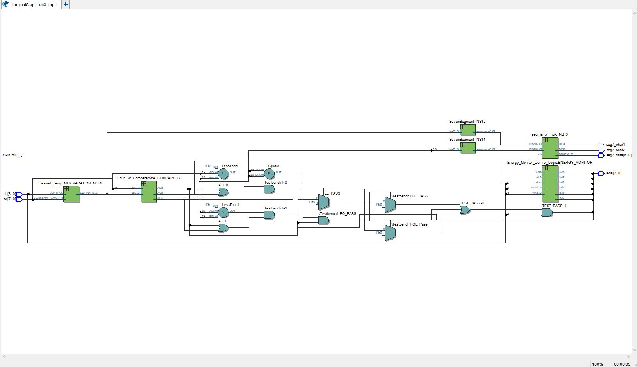

Compilation report

